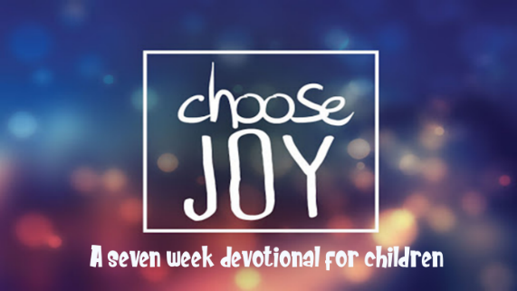

This kid’s devotional was created for older kids ages 8-13 in order to enable them to have a daily Bible study. There are 7 lessons in this series and each lesson has 6 days of questions regarding the book of Philippians. The daily questions can be the basis of a family devotional time. In addition, we recommend that your kids keep a personal journal as they go through the devotional each day. They can write down the answers to the questions, or their own observations from the Bible reading.

Monday: Read Philippians 2:12-16
- From verse 12 what did the Philippians do when Paul was present and when he was absent?
- Do you only obey when others are watching you? How is your obedience (whether someone is watching or not) affected when you remember that God is always watching you?
- Read Matthew 7:24 and James 1:22-24. What two things are important for every believer?
Note: You work out your salvation when you hear God’s words and put them into practice.
- What has God told you to do that you need to put into practice? (If nothing comes to mind, stop right now and pray that God would show you what He is asking you to do and when He shows you write it down and pray for Him to help you to do what He says.)

Tuesday: Read Philippians 2:12-16
- Fill in the blanks: Do _______ things without _______________ and ________________.
- What do you complain about? Will you ask God to forgive you for complaining and put this verse into practice?
- Memorize Philippians 2:14.

Wednesday: Read Philippians 2:12-16
- What should God’s children be doing in the corrupt culture we live in (verse 15)?
- How is your life any different than the culture you live in?
- How much time did you spend in God’s Word this week?

Thursday: Read Philippians 2:17-18
- What was Paul’s attitude and what did he want the Philippians to do as well?
- Take some time to thank God for His blessings to you. What difficulties in your life will you thank Him for?

Friday: Read Philippians 2:19-24
- Who do you know that desires to live a Godly, Christian life?
- Would others say that you are focused on Christ or on yourself?

Saturday: Read Philippians 2:25-30
- From verse 29 what did Paul tell the Philippians to do for Epaphroditus?
- Name some people you know who have been servants of Christ for you and have served you by teaching you and leading you to Him?
- How can you honor those who have served Christ in your life?
- What was the most meaningful thing you learned from these passages?

This devotional was made available by ministry-to-children.com

