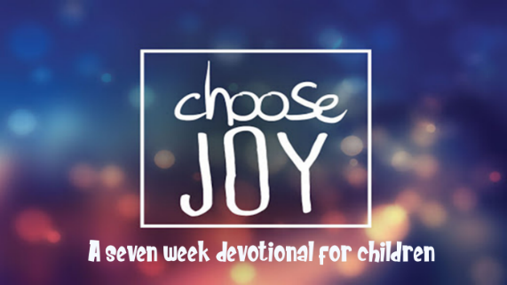

This kid’s devotional was created for older kids ages 8-13 in order to enable them to have a daily Bible study. There are 7 lessons in this series and each lesson has 6 days of questions regarding the book of Philippians. The daily questions can be the basis of a family devotional time. In addition, we recommend that your kids keep a personal journal as they go through the devotional each day. They can write down the answers to the questions, or their own observations from the Bible reading.

Monday: Read Philippians 4:4
- From these verses what are some reasons to rejoice?
a. Psalm 63:7 ________________________________________________________________________________
b. Matthew 5:12______________________________________________________________________________
c. Luke 13:17_________________________________________________________________________________
d. John 16:22_________________________________________________________________________________
e. Romans 5:11_______________________________________________________________________________
f. 1 Peter 4:12-13_____________________________________________________________________________
- What are some reasons you have to always rejoice in the LORD? When is it difficult for you to rejoice?

Tuesday: Read Philippians 4:5
- Why do believers need to be gentle with everyone?
a. 2 Samuel 22:36_____________________________________________________________________________
b. Proverbs 25:15_____________________________________________________________________________
c. Matthew 11:29_____________________________________________________________________________
d. Galatians 5:22-23___________________________________________________________________________
e. 2 Timothy 2:24_____________________________________________________________________________
- Who do you have a difficult time being gentle with? How can these verses help you to be gentler?

Wednesday: Read Philippians 4:5
- What does it mean that the Lord is at hand? (See James 5:8)
- Read Revelation 22:7, 12. Why is it important to obey God’s Word every day?
- How are you living in such a way that you are looking for Jesus to return at any moment?

Thursday: Read Philippians 4:6-7
- What are some things that are happening in the world that would cause people to be anxious?
- What are some things that make you anxious (worry)?
- In verse 6, what should you do when you are tempted to worry?
- What does God give believers who obey verse 6 (found in verse 7)?

Friday: Read Philippians 4:8-9
Note: To meditate is to think about continually. Verse 8 gives us many things to think upon to protect us from anxiety.
- What are some things that are true that you can think on?
- What are some things that are noble (morally good) and pure that you can think on?
- What do you need to remove from your life that is not helping you to think on these things?

Saturday: Read Philippians 4:8-9
- Another word for good report is admirable. What are some admirable things you can think about?
- What do you spend most of your day thinking about? Do your thoughts line up with what Paul says believers should continually think upon?
- Write down how this study has helped you experience God’s peace and His presence as you have tried to put into practice what you have learned this week

This devotional was made available by ministry-to-children.com

