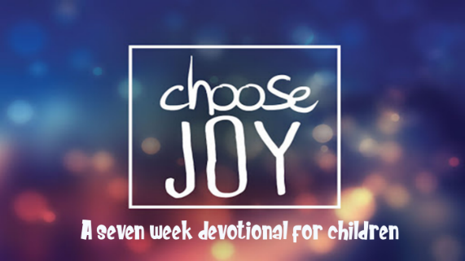

This kid’s devotional was created for older kids ages 8-13 in order to enable them to have a daily Bible study. There are 7 lessons in this series and each lesson has 6 days of questions regarding the book of Philippians. The daily questions can be the basis of a family devotional time. In addition, we recommend that your kids keep a personal journal as they go through the devotional each day. They can write down the answers to the questions, or their own observations from the Bible reading.

Monday: Read Philippians 3:15-16
Note: It is important to always pray and ask the Holy Spirit to give you an understanding of the Scripture you are studying. If you still have difficulty, read in another version to get a better understanding.
- From verse 16 what is Paul saying the believers should have?
- How are you living in unity with those whom you don’t always agree with?

Tuesday: Read Philippians 3:17-19
- Whose example should the Philippians follow?
- From the following passages whose example should you imitate?
a. Hebrews 6:12__________________________________________________
b. Hebrews 13:7__________________________________________________
c. 3 John 1:11____________________________________________________
- Name some people that God would want you to imitate because their life is an example of following Christ. Is there someone in your life that is a bad example that you should not follow?

Wednesday: Read Philippians 3:17-19
- What is the future of the enemies of Christ? (Verse 19)
- Give an example of setting your mind on earthly things.
- What are some earthly things you set your mind on?
- Read Colossians 3:1-2. Will you pray that God will help you keep your mind on things of Christ?

Thursday: Read Philippians 3:20-21
- The state of being vested with the rights, privileges, and duties of a citizen.
- The character of an individual viewed as a member of society; behavior in terms of the duties, obligations, and functions of a citizen: an award for
- What are some privileges for a citizen of heaven?
- How does your behavior cause others to know you are a citizen of heaven? What behaviors need to change with God’s help so you can look more like a citizen of heaven?

Friday: Read Philippians 3:20-21
- Who are we eagerly waiting for and why?
- 13. What does 1 John 3:2 say believers will be like when we see Jesus?
- How does Christ’s soon return affect the way you live? Will you pray that each day your focus will be upon Jesus and His soon return?

Saturday: Read Philippians 4:1-3
Note: Stand firm-being steadfast-keeping a steady gaze on Christ and your future with Him.
- What do these verses say about standing firm (stand fast)?
a. 1 Corinthians 16:13(NKJV) ___________________________________
b. Isaiah 7:9b (NIV)____________________________________________
c. 1 Corinthians 15:58 (NIV)____________________________________
d. Ephesians 6:14 (NIV)________________________________________
e. 2 Thessalonians 2:15 (NIV) ___________________________________
f. James 5:8 (NIV)_____________________________________________
g. 1 Peter 5:8-9 (NIV)_____________________________________________
- As you studied this lesson, what was most meaningful to you and why?
- Scripture Memory: Philippians 3:20 For our citizenship is in heaven, from which we also eagerly wait for the Savior, the Lord Jesus Christ,

This devotional was made available by ministry-to-children.com

